Winter Youth Retreat Registration Guide
(January 2024)
Amigo has a new camp management software, Camp Brain, so registration looks different this year than in years’ past. Your church’s first time using this software to register for Winter Youth Retreat will be unintuitive, but successive registrations will be much simpler.
Before you start, we highly recommend using a church or youth-group-related email address to log-in or sign-up.The church email address that you used on our old software (UltraCamp) should still work. Save your username (email address) and password to use in subsequent years. If you have any issues signing in, contact Colton Eby, Youth Program Director, at colton@amigocentre.org.

To Register for Winter Youth Retreat:
- Sign in to Camp Brain using your youth group’s account.
- Select Winter Youth Retreat.
- Add each youth who will be attending as persons on your youth group’s account.
Use the following naming conventions: Gender Youth # ChurchName or Gemder Sponsor # ChurchName.
- M Youth #1 BerkeyAvenue
- F Youth #1 BerkeyAvenue
- M Sponsor #1 BerkeyAvenue
- F Sponsor #1 BerkeyAvenue
You will be able to use these names for future WYRs without adding or deleting the names of attendees that come and go over time. This will also help Amigo Staff with each church’s room assignments.
- Add Winter Youth Retreat (Combined) to your cart for each person on your account.
This is the longest part of the process. As you add the sessions, they will show up on the right side of your screen under the person registered.
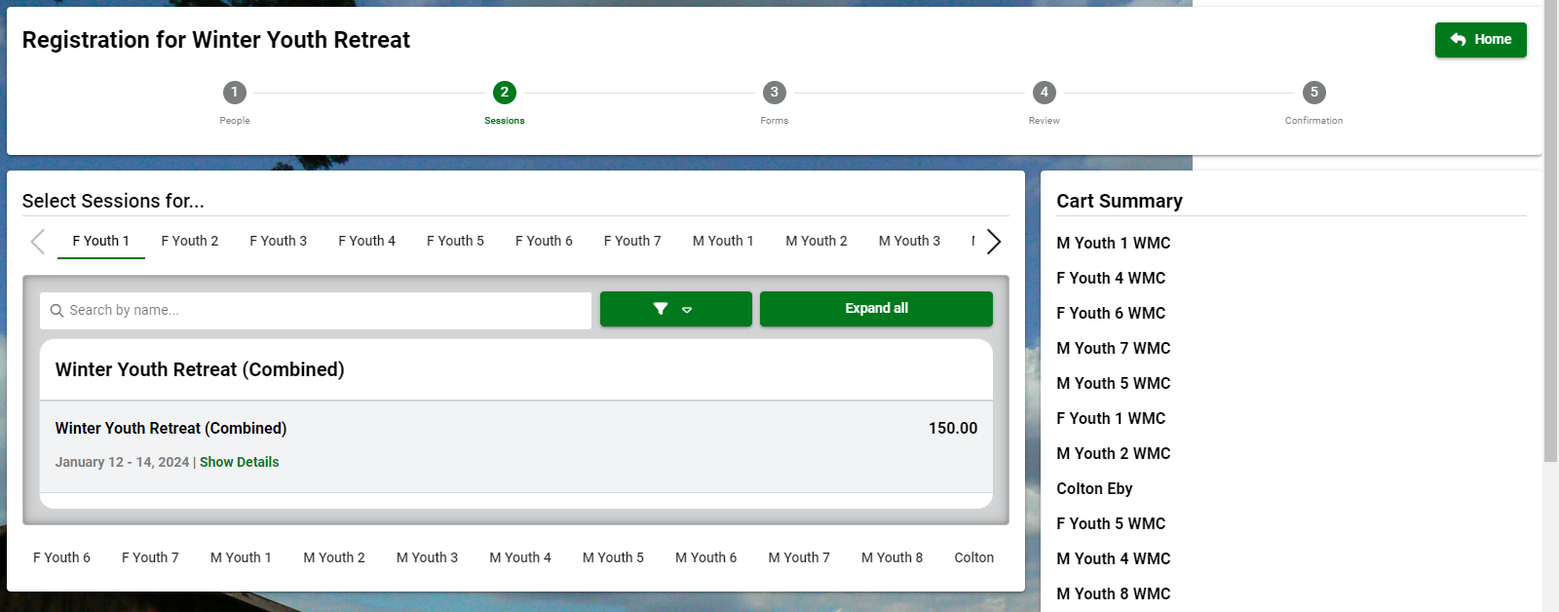
- Once every youth & sponsor has been signed up, scroll to the bottom of the page and click Continue.
- Fill out the Main Household Form (required) at the top of the screen, as well as Medical Forms for attendees with special needs.
If you have any attenders with allergies (food or environmental), extra accommodation needs, or other information relevant to Amigo, please choose a corresponding account and fill out the Medical Form. Include the name of the attender in the allergy list box.
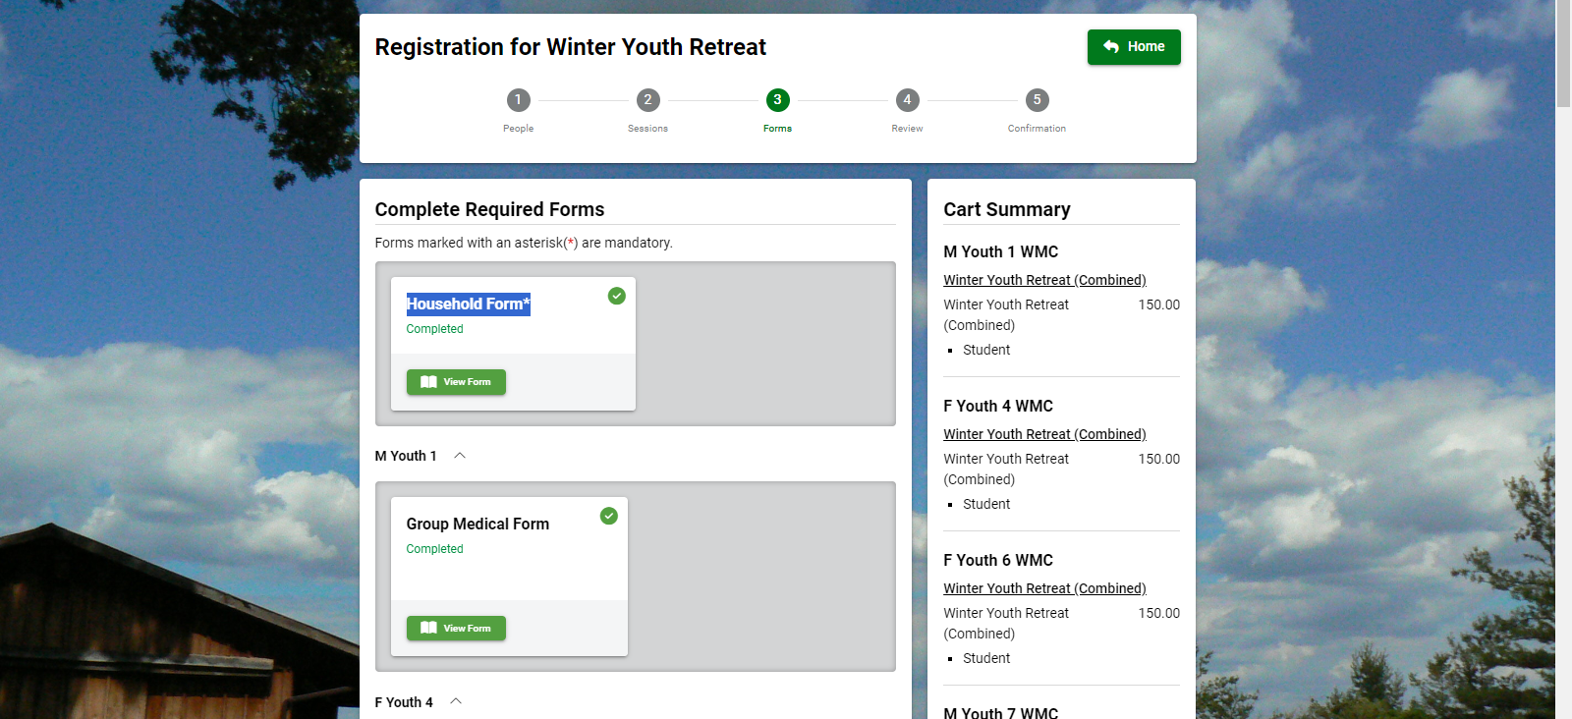
- Scroll to the bottom and click Continue to Payment
Your non-refundable deposit is required at registration. Your remaining balance is due at check-in, but it can be paid online anytime before your arrival.

